Towerfull

Authors :

* Thomas Vuilleumier
* Sebastian Diaz
* Lionel Pollien

Source : [Isometric tower defense game tower sprite on Craiyon](https://www.craiyon.com/image/TE1RQ3J6R-a4ZzwBaKe8hA)

# Project context

During the HEIG-VD’s MCR course, we are asked to create a project using a certain prototype, one per group. Our model is Prototype, and aims to create instances of a class by cloning another instance. To exploit this, we chose to create a tower defense we chose to call Towerfull.

The use of Prototype in our project resides in two main parts:

* The saves: in the rest of the report, you’ll hear about the GameArea. It’s the center of our game, it’s the conceptual board, and it’s a Prototype. We clone the gameArea, storing it as a save, which we can load later. As such, these aren’t copies that are saved to the disk.
* The factories: our enemies and protections are standardized, and as such we store their instances in factories and clone them when we need them.

This project was made using the library libGDX, coming from a recommendation from the teacher.

# Launching the project

**Clone the repository**

$ git clone [git@github.com:Cobora2001/Towerfull.git](mailto:git@github.com:Cobora2001/Towerfull.git)

**Go in the folder**

$ cd Towerfull

**Launch the game**

From an IDE:

- Open *./lwjgl3/src/main/java/io.github.towerfull.lwjgl3/Lwjgl3Launcher* in your IDE

- From there, there is a **public static void main(String[] args)** method that you can use. This will launch the game.

From the command line:

- Launch the command: $ ./gradlew lwjgl3:run

- If needed, you can do a clean build: ./gradlew

# UML

…We did what we could, sorry.

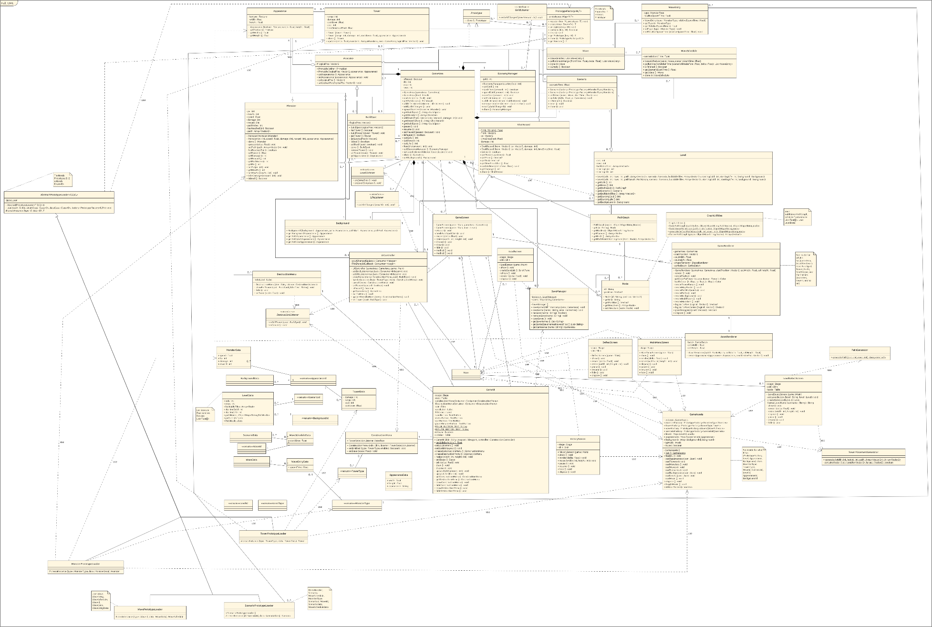

# Understanding our code

## Path

We define our path in the Level. It’s designed as an oriented graph (PathGraph), composed of Nodes. Our Nodes store their successor. These graphs should never have cycles. Any point of the graph that doesn’t have predecessors is a spawn point, any point that doesn’t have a successor is an end point, that the player needs to defend. This method via a graph was done so that we could have multiple paths possible. Our generated levels don’t support it yet.

## Monster

A monster is an entity that can be killed and will attack in our game. They have life, speed, damage, a reward for when we will them, a path they follow (an Array<Vector2>, which is one of the possible routes that our graph describes).

## Wave

A wave is a tool that allows us to define when a monster will spawn. It contains WaveEntries, which serve as storage for both a MonsterType (which allows us to go and get that monster from the factory) and a time at which the monster can spawn relative to the wave.

## Scenario

A scenario is a storage of waves and times that defines the entire timeline of monster spawning. For each wave, we define a starting time. A monster from that wave will be spawned at the time its wave starts plus the time stored in its WaveEntry. It has a factory to create the monsters, its own instance, cloned from GameAssets (see later).

## Tower and BuildSpot

A Tower is a defense mechanism that shoots monsters. A BuildSpot is a place where a tower could be placed, or is placed. If no tower is built in a BuildSpot, it will be available as a button to be built upon. If a tower is there, the tower can be clicked to give the player the option to destroy it, getting back a portion of the money invested, as well as the space available for a new build.

## Level

A level is a structure that defines dimensions for the playing board (GameArea), as well as the path described above. It contains places to install BuildSpots, a Scenario, the starting gold and life for the level, and the appearance of the different elements (Background, which defines how the path looks, how the spawn points look, and so on).

## GameAssets, AbstractPrototypeLoader, and PrototypeFactory

We manage our assets centrally. This allows us to dispose of them in one go, without forgetting any. This is done in GameAssets. It loads the assets from JSONs (using data classes, enums, and implementations of AbstractPrototypeLoader for the loading of Prototypes). It’s then either stored in maps for levels, appearances and backgrounds, or in a PrototypeFactory for the Prototypes (monsters, towers, waves, and scenarios) (or in a Skin for the single skin we use for the buttons, or a Music for the music).

# What to do from there…?

There are still many points for which we started planning but didn’t have time to implement. These include, but are not limited to:

* Adding spells to weaken monsters (modifying the scenario’s prototype, which is why each scenario has its own, so that it can be affected to make use of Prototype even more)
* Adding specific towers that would be traps on the way
* Adding a survival mode, where the waves become harder and harder and never stop
* Adding the option to upgrade towers
* Fixing UI for smaller windows
* Giving a list of Scenarios to a Level, then setting the scenario randomly from among them
* Change tower attack mechanic (it currently attacks the monster that spawned first in range, which may not always be very intuitive)
* Better balancing
* Make it so that generated levels can have multiple paths
* Make level progression a thing (unlock levels as you go), and add levels
* Create difficulty levels
* Add background decors to make it more beautiful
* Add animations
* Add projectiles (not instant, but moving, with appearances, speed, and so on)
* Add a campaign (life is kept in between levels, that kind of thing)
* Make monsters and/or towers do some other effects (weaken/slow monsters, destroy towers, do zone attacks, that kind of things, spawn more monsters when a monster dies)
* And so on…

# Conclusion

We had fun making this project and using Protoype, it’s an interesting tool which made it quite easy to manage the factories and so on. As mentioned, there is still a lot more that we could do with this, either for corrections (mostly with the displays given changes to the size of the screen) or to make it better, but we have to stop at some point.

We hope you’ll enjoy testing it, we tried not to make it too easy for you, while still being possible. Don’t be ashamed to pause, otherwise it can go fast, and don’t forget that saves don’t survive a relaunch. If you don’t want the music, it can be muted in the main menu.

Have fun !

* Team Prototype

Source: [Castle in the distance by shotguncze on DeviantArt](https://www.deviantart.com/shotguncze/art/Castle-in-the-distance-864482856)